Genstat Summer School Scholarship Project
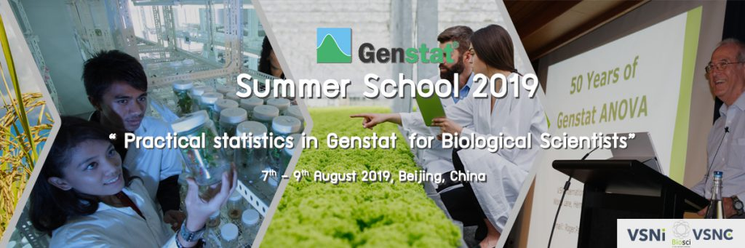

Genstat Summer School 2019

– Practical statistics in Genstat for Biological Scientists –
OVERVIEW
On behalf of VSN international Ltd. We cordially invite you to our international seminar “Genstat Summer School 2019” that will take place in Beijing , China on 7th – 9th August 2019.
This Summer School brings together biologists, statisticians, geneticists and students actively engaged in applying modern tools Genstat to improve statistical data analysis. The invited professor is famous statistical consultant and researcher from Rothamsted, and the course is in English.
We warmly welcome you, coming from various research centers and universities across the world to attend this summer school and apply for the scholarship for this course!
TRAINER
Prof. Dr. Roger Payne, Chief Science and Technology Officer, Rothamsted
Apply for Scholarship
This Summer School provides scholarships for outstanding students. Each successful student receives a 5200 CNY (740 USD) discount towards the training fee. VSN China is responsible for the scholarship organization and application. Please fill the application form and send it to China@vsni.co.uk before 28th, June.
Deadline for application:
June 28th, 2019
CONTACT US
Support Team
Email: china@vsni.co.uk
Tel: +86 (0)10 6268 0244
Web：www.vsnc.com.cn

Application form for Genstat Summer School Scholarship
Please fill the form and send it to China @vsni.co.uk before 28th, June. we will give the feedback within 3 working days.
Email title：Name+ organization+ Genstat Summer School Scholarship
Name
Organization
Country
Grade
Tel
Email
Research field
Supervisor’s name
Supervisor’s email
How do you get the message?
Are you a Genstat user?
Note:
please register online if you receive the scholarship in 2 working days.
http://www.vsnc.com.cn/event-cn/Genstat-summer-school-2019/
VSNC Tel：010-62680244/010-88400822.
Email: china@vsni.co.uk

